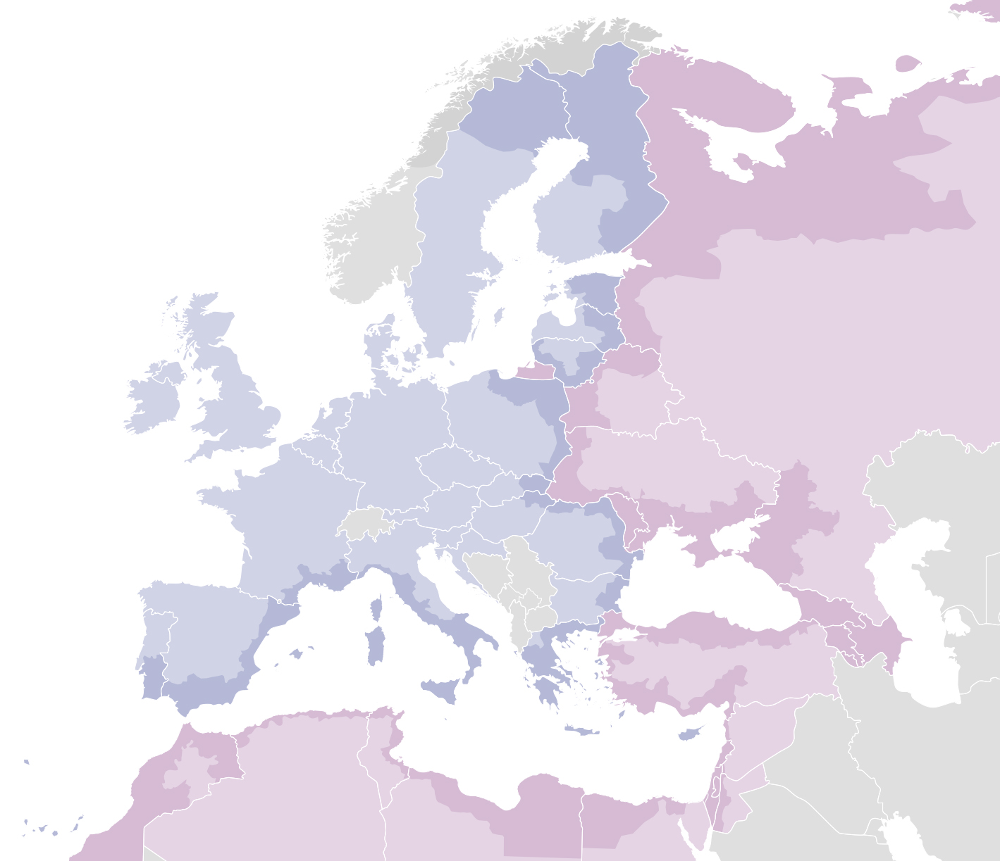
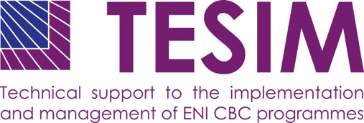

DISCLAIMER

This non-binding document has been developed by the TESIM project.

It does not necessarily reflect the views of the European Commission on the topic, and is presented to programme practitioners for illustrative purposes only.

Annexes to

Factsheet on
result-oriented monitoring
(ROM)

SEPTEMBER 2019

Annex I: ROM checklist – monitoring questions for project ROM

Question | Grade | Findings
Relevance
  - Does the project presently respond to the needs of the target groups?
- Does the project intervention logic still work as intended for the target groups/ end beneficiaries?
- Is the project design still appropriate?
- How does the project solve the needs of the target groups/ end beneficiaries?
1.2. Is the project adapted to the present institutional, human and financial capacities of the beneficiaries and/ or other key stakeholders?
- Does the project correspond to the existing capacities of the project beneficiaries?
- Is the project addressing the problem in a more advanced manner compared to the interventions in the past?
1.3 Do all key stakeholders demonstrate effective commitment (ownership)?
- Are the project beneficiaries enthusiastic about implementation of the project?
- Do the project beneficiaries identify any functions that experience problems due to lack of commitment (ownership)?
- Have all project beneficiaries been actively involved into the planning and implementation of the project so far?
1.4. Have all relevant circumstances and risks been taken into account to update the intervention logic?
- Have changes intervened since the start of the project? And if this is the case, how are they reflected in the intervention logic?
- Have any problems (risks) emerged? If the case, how are they addressed?
1.5. Are there any complementarity issues with other on-going/finalised action(s) managed by donors that need to be addressed?
- Are there other on-going or finalised projects solving the problem addressed by the project?
- Is there a possibility for duplication or synergies?
1.6. Indicators
- Are the indicators to measure results well defined and relevant to measure the achievement of the objectives?
- Are the defined output indicators appropriate?
- Are the project indicators coherent with those on the programme level?
- Are baselines and targets set for each indicator? Are the targets realistic?
Findings on “Relevance”
Highlight the most important findings relating to the performance of the project and elaborate on them in detail while also pointing out any critical issues and/or serious deficiencies. Findings are accurate, concise and direct. They must be based on and coherent with their answers to the monitoring questions.
Efficiency
2.1. Are the chosen project implementation mechanisms conducive for achieving the expected results?
- Are the roles and responsibilities well divided and clear to all beneficiaries?
- Is the internal communication and coordination clear to all beneficiaries and is it working?
2.2. Inputs
- Do the resources actually made available correspond to the needs of the project?
- If relevant: to what degree are the resources other than EU funded made available?
2.3 Delays
- If there are delays, how important are they and what are the consequences?
- What are the reasons for these delays and to what extent have appropriate corrective measures been implemented?
- To what extent has the planning been revised accordingly?
2.4. Have the outputs been produced/ delivered in a cost-efficient manner?
- Are the outputs produced in accordance with the planned project budget?
- Is the ratio of the produced outputs and the spent funds proportionate?
2.5. Is the project adequately monitored by the project beneficiaries?
- Is the project monitoring and reporting system operational?
- Does it ensure collection of the necessary information/ data?
- Is there a project steering committee? If yes, what are its functions?
Findings on “Efficiency”
Highlight the most important findings relating to the performance of the project and elaborate on them in detail while also pointing out any critical issues and/or serious deficiencies. Findings are accurate, concise and direct. They must be based on and coherent with their answers to the monitoring questions.
Effectiveness
3.1. Is the progress of each output conforming to plan?
- Is the delivery of outputs in line with the plan?
- To what extent is the expected progress in terms of outputs satisfactory?
- If there are deviations, what are their implications?
3.2. Is the quality of outputs satisfactory?
- Based on your experience, what is the quality of outputs?
- Do these outputs meet expectations of the grant beneficiaries and the target group(s)?
3.3. Are the outputs still likely to lead to the expected results?
- What is the level of achievement of results as reflected by indicators covering the specific objective?
- Will the results be obtained within the set timeframe?
- Are any corrective measures needed?
3.4. Does the project effectively support the policy and actions of the beneficiaries?
- Is there evidence that the project supports implementation or development of the beneficiaries (and where relevant - regions and countries) policies?

Findings on “Effectiveness”
Highlight the most important findings relating to the performance of the project and elaborate on them in detail while also pointing out any critical issues and/or serious deficiencies. Findings are accurate, concise and direct. They must be based on and coherent with their answers to the monitoring questions.
Sustainability
4.1. Are key stakeholders acquiring the necessary institutional and human capacities to ensure the continued flow of benefits?
- Is there evidence of strengthening the human, organisational capacities?
- Is there an adequate level of human and institutional capacity put in place to continue delivering project’s benefits upon finalisation of the project implementation period?
4.2. Is access to the benefits affordable for target groups on the long term?
- What is the financial contribution necessary to use the project benefits by the target groups?
- Can the target groups afford to cover the future running costs related to the continued access to the benefits of the project?
4.3. Have the relevant organisations taken the financial measures to ensure continuation of services after the end of the project?
4.4. Has the private sector been involved to ensure sustainability of the project?
Findings on “Sustainability”
Highlight the most important findings relating to the performance of the project and elaborate on them in detail while also pointing out any critical issues and/or serious deficiencies. Findings are accurate, concise and direct. They must be based on and coherent with their answers to the monitoring questions.
Horizontal issues
5.1. To what extent have the recommendations provided in the previous ROM missions/ other monitoring activities been taken into account?
5.2. Have the communication and visibility actions been implemented in an appropriate manner?
5.3. Are there good practices inherent to the project which could be useful to share beyond the project context?
5.4. Have the necessary measures been taken to address the environmental sustainability?
5.5. Have the necessary measures been taken into account to enhance the role of women?
Gender
Environment
Findings on “Horizontal issues”
Highlight the most important findings relating to the performance of the project and elaborate on them in detail while also pointing out any critical issues and/or serious deficiencies. Findings are accurate, concise and direct. They must be based on and coherent with their answers to the monitoring questions.

Annex II: ROM checklist – monitoring questions for programme ROM

Question | Grade | Findings
Relevance
  - Does the programme presently respond to the needs of the target groups/ end beneficiaries?
- Are the selected thematic objectives and programme priorities still relevant to the target groups/ end beneficiaries?
- What is the response to the calls for proposals of the programme?
- If relevant, are the LIPs responding to the local/regional needs?
1.2. Is the programme adapted to the present institutional, human and financial capacities of the programme bodies and national authorities (incl. CCP, GoA) and/ or other key stakeholders?
- Do the entrusted tasks correspond to the existing capacities of the programme bodies and authorities?
1.3 Do all key stakeholders demonstrate effective commitment (ownership)?
- Are the stakeholders involved into management and monitoring of programme implementation enthusiastic about the programme?
- Have all programme stakeholders been actively involved into the planning and implementation of the programme so far?
- Do the stakeholders at the project level demonstrate commitment to the CBC?
1.4. Have all relevant circumstances and risks been taken into account to update the programme intervention logic?
- Have changes intervened since the start of the programme? And if this is the case, how are they reflected in the intervention logic?
- Have any problems (risks) emerged? If the case, how are they addressed?
1.5. Are there any complementarity issues with other on-going/planned action(s) managed by donors that need to be addressed?
- Are other donors providing support to the thematic areas addressed by the programme?
- Is there a possibility for duplication or synergies?
1.6. Indicators
- Are the programme indicators to measure results well defined and relevant to measure the achievement of the objectives?
- Do the projects contribute to achievement of the output indicators defined on the programme level?
- Will the outputs and results generated by the projects lead to the achievement of the programme results?
- Are the targets set for each indicator realistic? Do they need to be revised or updated?
Findings on “Relevance”
Highlight the most important findings relating to the performance of the programme and elaborate on them in detail while also pointing out any critical issues and/or serious deficiencies. Findings are accurate, concise and direct. They must be based on and coherent with their answers to the monitoring questions.
Efficiency
2.1. Are the chosen implementation mechanisms conducive for achieving the expected results?
- Are the roles and responsibilities well divided and clear to all bodies and authorities involved into programme management?
- How efficient are the mechanisms for selection and contracting of projects (calls for proposals, direct award)?
- How efficient is the communication of the programme requirements to the project applicants/ beneficiaries?
2.2. Do partner government and other partners in the country effectively steer the programme?
- Are the bodies involved in the national management and control system participating in the programme implementation according to their tasks?
- Are the national delegations in the Joint monitoring committee effectively steering programme monitoring and implementation?
2.3. Inputs
- Do the resources actually made available correspond to the needs of the programme?
- If relevant: to what degree are the resources other than EU funded made available?
- Does the commitment of the programme budget correspond to the financial tables in the JOP?
- Is there a need for reallocation of programme resources (time-wise or from one TO to the other)?
2.4. Delays
- If there are delays, how important are they and what are the consequences?
- What are the reasons for these delays and to what extent have appropriate corrective measures been implemented?
- To what extent has the planning been revised accordingly?
2.5 Have the outputs been produced/ delivered in a cost-efficient manner?
- Is the ratio of the produced programme outputs and the spent funds proportionate?
2.6 Is the programme adequately monitored by the key stakeholders?
- Is the programme monitoring and reporting system operational? Is the collection and aggregation of the project data on-going?
- Does it ensure collection of all necessary information/ data for reporting?
- What is the role of the Joint monitoring committee in the programme management and monitoring?
- Are the monitoring and evaluation activities of the programme relevant to its implementation stage?
Findings on “Efficiency”
Highlight the most important findings relating to the performance of the programme and elaborate on them in detail while also pointing out any critical issues and/or serious deficiencies. Findings are accurate, concise and direct. They must be based on and coherent with their answers to the monitoring questions.
Effectiveness
3.1. Is the progress of each output conforming to plan?
- Is the implementation of the programme in line with the workplan in the JOP and the annual work programmes?
- If there are deviations, what are their implications?
- To what extent are the contracted projects being implemented in accordance with their plans?
3.2. Is the quality of outputs satisfactory?
- Will projects contracted under the specific programme priorities deliver planned outputs? What is their quality?
- Are the selected projects producing outputs and results that contribute to achievement of the programme objectives?
3.3. Are the programme outputs still likely to lead to the expected results?
- What is the level of achievement of results as reflected by indicators covering each programme priority?
- Will the results be obtained within the set timeframe?
- Are any corrective measures needed?
3.4. Does the programme effectively support the policy and actions of the beneficiaries?
- Is there evidence that the selected projects support implementation or development of the beneficiaries (and where relevant - regions and countries) policies?
Findings on “Effectiveness”
Highlight the most important findings relating to the performance of the programme and elaborate on them in detail while also pointing out any critical issues and/or serious deficiencies. Findings are accurate, concise and direct. They must be based on and coherent with their answers to the monitoring questions.
Sustainability
4.1. Are key stakeholders on programme and project level acquiring the necessary institutional and human capacities to ensure the continued flow of benefits?
- Is there evidence of strengthening the human, organisational capacities of beneficiaries, as well as programme bodies and authorities?
- Is there an adequate level of human and institutional capacity put in place to continue delivering benefits to the programme area upon finalisation of the programme implementation period?
4.2. Is access to the benefits affordable for target groups on the long term?
- Does the programme request its projects to ensure affordable access to the project results to the target groups?
- Is there assurance that the benefits delivered by the projects will be further sustained?
4.3. Have the relevant organisations and authorities taken the financial measures to ensure continuation of services after the end of the project/ programme?
4.4. Has the private sector been involved into projects supported by the programme to ensure sustainability of the results?
Findings on “Sustainability”
Highlight the most important findings relating to the performance of the programme and elaborate on them in detail while also pointing out any critical issues and/or serious deficiencies. Findings are accurate, concise and direct. They must be based on and coherent with their answers to the monitoring questions.
Horizontal issues
5.1. To what extent have the recommendations provided in the previous ROM missions/ other monitoring activities been taken into account?
5.2. Have the communication and visibility actions been implemented in an appropriate manner?
5.3. Are there good practices inherent to the programme which could be useful to share beyond the programme’s context?
5.4. Have the necessary measures been taken to address the environmental sustainability?
5.5. Have the necessary measures been taken into account to enhance the role of women?
Findings on “Horizontal issues”
Highlight the most important findings relating to the performance of the programme and elaborate on them in detail while also pointing out any critical issues and/or serious deficiencies. Findings are accurate, concise and direct. They must be based on and coherent with their answers to the monitoring questions.

Annex III: Executive report on project ROM
Overall information on the ROM
Dates of the ROM exercise (incl. desk phase)
Name of the ROM expert
Countries and partners visited/ interviewed
Report date
Key information on the project
Project ID
MA/JTS staff member following the project
Starting and end date of the project
Project partnership
Short summary of the project
Total project budget
Grant size
Project budget spent (disbursed)
Conclusions
Analytical summary, based on the facts listed in the findings
Criteria | Conclusions
Relevance
Efficiency
Effectiveness
Sustainability
Horizontal
Recommendations
Recommendations are derived from the conclusions and address issues of major importance to the performance of the project. Recommendations must be realistic, feasible and drafted in a way that the stakeholders to whom they relate are clearly identified. They must take in consideration applicable rules and other constraints, related for example to the context in which the project is implemented. They must not be phrased in general terms but constitute clear proposals for solutions and they target the most important issues rather than minor or less relevant aspects of a project..
Number | Recommendations | To whom is the recommendation is addressed (Lead beneficiary, JTS, MA, etc.)
1
2
3

Comments by the MA/JTS
Comments on conclusions
Comments on recommendations

Follow-up plan by the MA/JTS
Activity | Link to the recommendation | Responsible | Deadline

Annex IV: Executive report on programme ROM
Overall information on the ROM
Dates of the ROM exercise (incl. desk phase)
Name of the ROM expert
Countries and partners visited/ interviewed
Report date
Key information on the programme
Programme name
Countries participating in the programme
Thematic objectives addressed by the programme
Total programme budget
Programme budget declared to the EC

Conclusions
Analytical summary, based on the facts listed in the findings
Criteria | Conclusions
Relevance
Efficiency
Effectiveness
Sustainability
Horizontal

Recommendations
Recommendations are derived from the conclusions and address issues of major importance to the performance of the programme. Recommendations must be realistic, feasible and drafted in a way that the stakeholders to whom they relate are clearly identified. They must take in consideration applicable rules and other constraints, related for example to the context in which the programme is implemented. They must not be phrased in general terms but constitute clear proposals for solutions and they target the most important issues rather than minor or less relevant aspects of a programme.
Number | Recommendations | To whom is the recommendation is addressed (JTS, MA, NA, EC etc.)
1
2
3

Comments by the MA/JTS
Comments on conclusions
Comments on recommendations

Follow-up plan by the MA/JTS
Activity | Link to the recommendation | Responsible | Deadline

Annex V: Short summary of the project/ programme (to be attached to ROM executive report)
Part 1 – Context
Summary of the programme/ project: a short text on the objectives of the project or programme and problems/ issues to be addressed by it, as well as a description of the target groups and beneficiaries.

This has to be an objective description and should not include appreciations and observations on issues related to the project or programme implementation.

Part 2 – Intervention logic
Summary of the intervention logic, including the indicators at the three levels of the intervention logic: overall objective/impact, specific objective/result, outputs.

This has to be an objective description and should not include appreciations and observations of the expert

