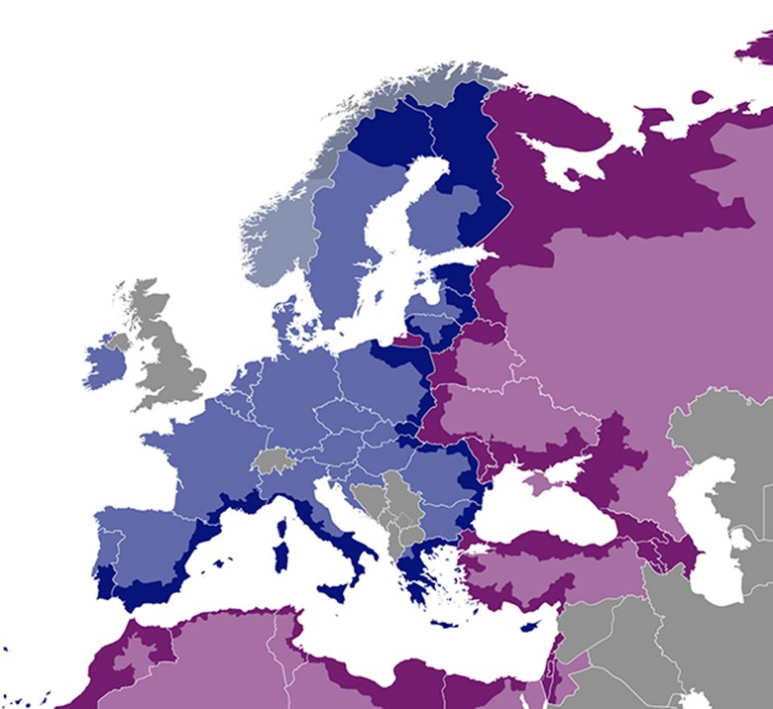
DISCLAIMER
This non-binding document has been developed by the TESIM project. It does not necessarily reflect the views of the European Commission on the topic, and is presented to programme and project practitioners for illustrative purposes only.
In case the document is endorsed by an ENI CBC programme and renders it compulsory for use by project beneficiaries, neither TESIM experts nor the TESIM consortium members shall be held liable for its contents, in particular as far as audit findings on the eligibility of expenditure are concerned.

Expenditure verification pack: contract beneficiary-auditor

Annex 2 to the adaptation for projects with subgrants of the “Fact sheet on expenditure and revenue verification report”

  - July 2020
A project funded by the European Union |  | Implemented by a consortium led by

Template of contract between the beneficiary and the auditor

SERVICE CONTRACT FOR THE EXPENDITURE AND REVENUE VERIFICATION
of a Grant Contract
under the [name of the ENI CBC programme]

[Title of and number of the grant contract]

[Name of beneficiary]

<Full official name of the beneficiary>
[<Official registration number>]
<Full official address>
[<VAT number>],
(‘the Beneficiary’),
of the one part,
and
<Full official name of the Contractor>
[<Official registration number>]
<Full official address>
[<VAT number>],

(‘the Auditor’)
of the other part,
have agreed as follows:
Article 1. Subject
1.1 The subject of this Contract is the individual <or consolidated> expenditure and revenue verification of the above-mentioned contract done in <Location> with identification number <contract reference> (‘the service’).
1.2 The Auditor shall execute the tasks assigned to him in accordance with the procedures and templates annexed to this Contract or any update issued by the Managing Authority or the Joint Technical Secretariat.
Article 2. Contract value
This Contract, established in [Euro] <or national currency>, is a global price contract. The contract value is [Euro] <national currency> <amount>.
Article 3. Order of precedence of contract documents
The following documents shall be deemed to form and be read and construed as part of this Contract, in the following order of precedence:
- the grant contract and its annexes;
- the partnership agreement;
- the call for subgrants;
- the subgrant contracts and their annexes
- annex I: description of the procedure;
- annex II: control checklist;
- annex II: template of individual report <or consolidated report>;
- annex III: template of list of findings;
- annex IV: template of report on suspected and/or established fraud.
The various documents making up the contract shall be deemed to be mutually explanatory; in cases of ambiguity or divergence, they shall prevail in the order in which they appear above. Addenda shall have the order of precedence of the document they are amending.
Article 4. Language of the contract
The language of the contract and of all written communications, including reports, between the Auditor and the Beneficiary shall be English <or French>.
Article 5. Communications
<Indicate here the contact persons, addresses of the Parties, their other contact details, the documents to provide and the procedure to be used by the Parties for communication.>
Article 6. Implementation of the tasks and delays
6.1 [The start date for implementation shall be <date/date of signature of the contract by both parties>]
6.2 The period for delivery of the reports to the Beneficiary is <30> calendar days from submission of each financial report by the Beneficiary.
Article 7. Responsibilities
7.1 The Beneficiary is responsible for providing the Financial Report, as well as giving access to its accounting, supporting documents and project documentation and physical investments to the Auditor, so that the procedures described in annex I can take place in due time and without restrictions.
7.2 The Auditor is responsible for performing the agreed-upon procedures described in annex I with due care and full respect of the Code of Ethics therein indicated, as well as submitting the reports to the Beneficiary. Additionally, the Auditor shall submit the ad hoc report directly to the Managing Authority in case of fraud. The Auditor will attend the specific trainings and meetings for Auditors organized by the competent Programme bodies. The Managing Authority may request the termination of the auditors not attending to these events.
Article 8. Reports
8.1 The Auditor shall submit the expenditure and revenue verification reports to the Beneficiary, with its annexes, following the templates and procedures established in the annexes mentioned in article3.
8.2 In case of identification of suspected and/or established fraud, the Auditor shall submit the report in annex IV without delay directly to the Managing Authority <or Joint Technical Secretariat> indicated in the grant contract. This report shall not be submitted to the Beneficiary.
Article 9. Approval of the reports
9.1 The financial reports from the beneficiaries and the expenditure and revenue verification reports shall be revised by the Managing Authority <or Joint Technical Secretariat> indicated in the grant contract after submission by the Lead Beneficiary. <These bodies will be supported by the Control Contact Points in the revision of these reports>.
9.2 Should the Managing Authority, the Joint Technical Secretariat or the Control Contact Points have any doubt concerning the findings indicated in the expenditure and revenue verification report, the Auditor will receive a request for clarification via the beneficiary, which will be answered in a maximum of <7> calendar days.
Article 10. Quality control by the programme bodies
10.1 The Managing Authority, the Joint Technical Secretariat or the Control Contact Points may carry out quality control of the work carried out, including the examination of the working papers, at any moment during the execution period of the grant contract.
10.2 As a result of the quality control, the Managing Authority may request to the Beneficiary the early termination of the contract with the auditors. Such termination shall be free of charge for the Beneficiary.
10.3 As a result of the quality control, the Control Contact Point may remove the Auditor from the long <or short> list of authorized auditors <or, in case of no list, the Managing Authority may exclude the Auditor from any work in the programme for any project during a period of time>.

Article 11 Administrative and financial penalty clauses
11.1 The Auditor who has committed substantial errors, leading to the significant amount of irregularities or fraud detected by the programme authorities or the European Commission, has made false declarations in supplying required information at the moment of the submission of the expenditure and revenue verification reports or has failed to supply such report in time or has been found in serious breach of its obligations under the Contract may be liable to:
- administrative penalties consisting of exclusion from performing expenditure and revenue verification within the ENI CBC programme in question for a maximum of <5 years> from the date on which the infringement is established; and/or
- financial deductions from <2%> up to <10%> of the contract value specified in Article 2, depending on the gravity and repeatability of the errors committed.
Article 12. Payment
Payments shall be made in accordance with the following instalments:

Report | [EUR] [<ISO code of national currency>]
1 | <X% of the contract value>
<n> | <X % of the contract value>
Final report | <X % of the contract value>
 | <Total contract value>

Article 13. Settlement of disputes and applicable law
12.1 Any disputes arising out of or relating to this Contract which cannot be settled amicably shall be referred to the exclusive jurisdiction of the courts of location of the Beneficiary.
12.2 This contract shall be governed by the law of the country of the Beneficiary.
Article 14. Data Protection
13.1 Any personal data included in the contract shall be processed pursuant to Regulation (EC) No 45/2001 on the protection of individuals with regard to the processing of personal data by the Community institutions and bodies and on the free movement of such data. The data shall be processed solely for the purposes of the performance, management and monitoring of the contract by the Beneficiary without prejudice to possible transmission to the bodies charged with monitoring or inspection in application of EU law. The Contractor shall have the right to access his/her personal data and to rectify any such data.
13.2 The data shall be confidential within the meaning of Regulation (EC) No 45/2001 of the European Parliament and of the Council on the protection of individuals with regard to the processing of personal data by Community institutions and bodies and on the free movement of such data. The Auditor shall limit access to the data to staff strictly needed to perform, manage and monitor the contract.
13.3 The Auditor undertakes to adopt technical and organisational security measures to address the risks inherent in processing and in the nature of the personal data concerned.
Article 15. Further additional clauses
<Add other relevant clauses.>

Done in English in two originals, on the <dd Month yyyy>

For the Contractor |  | For the Beneficiary
Name: |  | Name:
Title: |  | Title:
Signature: |  | Signature:
Date: |  | Date:

Only in case the country has set up a long or short list of auditors

