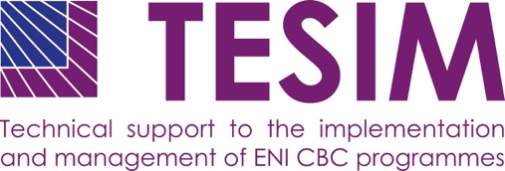
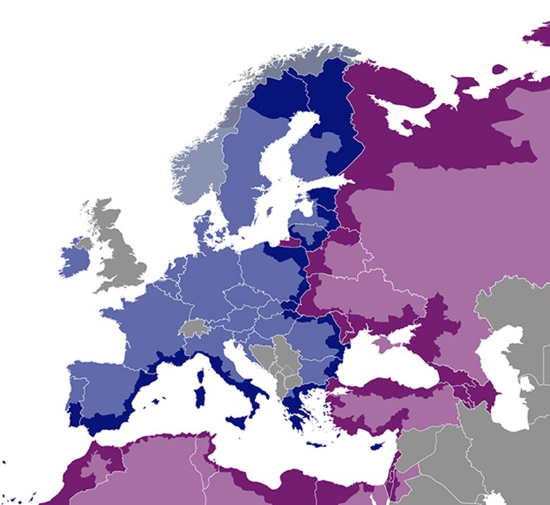
DISCLAIMER
This non-binding document has been developed by the TESIM project. It does not necessarily reflect the views of the European Commission on the topic, and is presented to programme and project practitioners for illustrative purposes only.
In case the document is endorsed by an ENI CBC programme and renders it compulsory for use by project beneficiaries, neither TESIM experts nor the TESIM consortium members shall be held liable for its contents, in particular as far as audit findings on the eligibility of expenditure are concerned.
A project funded by the European Union |  | Implemented by a consortium led by

Expenditure verification pack: individual report

Annex 4 to the adaptation for projects with subgrants of the “Fact sheet on expenditure and revenue verification report”

  - July 2020

Template of individual expenditure and revenue verification report

INDIVIDUAL EXPENDITURE AND REVENUE VERIFICATION REPORT
of a Grant Contract
under the [name of the ENI CBC programme]

[Title of and number of the grant contract]

<Name of the legal representative >, < Position>
<Beneficiary’s name>
<Address>
<dd Month yyyy>
Dear <Name of the legal representative>,
In accordance with the <name of the expenditure verification procedure in the respective programme>, we provide our Expenditure Verification Report (‘the Report’), with respect to the accompanying Individual Financial Report for the period covering <dd Month yyyy — dd Month yyyy> (Annex 1 of this Report) in connection with the Grant Contract <title and number of the contract>, the ‘Grant Contract’.
Objective
Our engagement was an expenditure and revenue verification procedure with regard to the Individual Financial Report for the Grant Contract between you <or your Lead Beneficiary> and <the Managing Authority>. The objective of this verification is for us to carry out certain procedures to which we have agreed and to submit to you a report of factual findings with regard to the procedures performed.
Standards and Ethics
Our engagement was undertaken in accordance with:
- International Standard on Related Services (‘ISRS’) 4400 Engagements to perform Agreed-upon Procedures regarding Financial Information as promulgated by the International Federation of Accountants (‘IFAC);
- the Code of Ethics for Professional Accountants issued by the IFAC. Although ISRS 4400 provides that independence is not a requirement for agreed-upon procedures engagements, the Contracting Authority requires that the auditor also complies with the independence requirements of the Code of Ethics for Professional Accountants;
Procedures performed
As requested, we have only performed the verification <procedures of the programme> to support the [Managing Authority] in assessing whether the expenditure claimed by you in the accompanying Individual Financial Report is eligible in accordance with the terms and conditions of the Grant Contract and eligibility rules of the Programme. The detailed procedures are found in the attached check-list in Annex 3.
Because the procedures performed by us did not constitute either an audit or a review made in accordance with International Standards on Auditing or International Standards on Review Engagements, we do not express any assurance on the accompanying Financial Report.
Factual Findings
The total expenditure subject of this expenditure verification  The amount is equal to the total amount of expenditure reported by you in the Individual Financial Report (annex 1). | EUR <x,xxx.xx>
The total expenditure verified and Expenditure Coverage Ratio  In case you applied sampling method to some heading or subheading of the budget, please indicate below this table for which headings or subheadings of the Financial Report sampling has been applied, the method used, the results obtained and whether the sample is representative | EUR <x,xxx.xx  <xx.xx%>
Expenditure complying with requirements set in the expenditure verification procedures  This amount represents the expenditure that, in our opinion, is in compliance with the eligibility rules of the Programme and requirements of the Grant Contract. | EUR <x,xxx.xx>
Expenditure not complying with requirements set in the expenditure verification procedures  This amount represents the expenditure that, in our opinion, is not eligible. | EUR <x,xxx.xx>
[If applicable] The total revenues and contributions by third parties verified is: | EUR <x,xxx.xx>
[If applicable, and only in the final report] The profit deriving from a surplus of income over expenditures is:  This amount represents the profit that, in our opinion, was generated by the project and thus this amount should be deducted from the payment. | EUR <x,xxx.xx>
Detailed breakdown of expenditure not complying, with the eligibility requirements is provided in the Annex 2 ‘List of factual findings’.
Use of this Report
The [Managing Authority] is not a party to the expenditure verification and therefore we do not owe or assume a duty of care to the [Managing Authority], who may rely upon this expenditure verification report at its own risk and discretion. The [Managing Authority] can assess for itself the procedures and findings reported by us and draw its own conclusions from the factual findings reported by us.
Yours sincerely,

Auditor’s signature [person or firm or both, as appropriate and in accordance with company policy]
Name of Auditor signing [person or firm or both, as appropriate]
Date of signature <dd Month yyyy> [date when the final report is signed]

