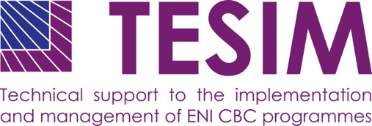
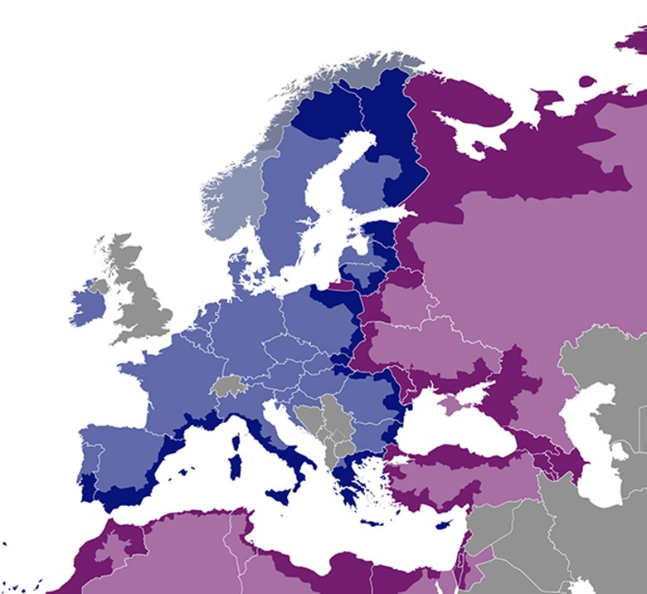

Expenditure verification pack: report on fraud

Annex 6 to the adaptation for projects with subgrants of the “Fact sheet on expenditure and revenue verification report”

  - July 2020
DISCLAIMER
This non-binding document has been developed by the TESIM project. It does not necessarily reflect the views of the European Commission on the topic, and is presented to programme and project practitioners for illustrative purposes only.
In case the document is endorsed by an ENI CBC programme and renders it compulsory for use by project beneficiaries, neither TESIM experts nor the TESIM consortium members shall be held liable for its contents, in particular as far as audit findings on the eligibility of expenditure are concerned.
A project funded by the European Union |  | Implemented by a consortium led by

Template of report on suspected and/or established fraud

REPORT ON SUSPECTED AND/OR ESTABLISHED FRAUD
of a Grant Contract
under the [name of the ENI CBC programme]

[Title of and number of the grant contract]

[Name of beneficiary]

I hereby inform the Managing Authority of the ENI CBC programme [name of programme] that, based on the provided documents, on my verification and my professional judgement as auditor [or controller in the case of public officers], I have become aware [and/or] found evidence of suspected fraud [and/or] established fraud for the above-mentioned project beneficiary.

- Typology of fraud
Please explain in detail the nature of suspected and/or established fraud that you wish to inform the Programme about

- Scope of expenditure concerned by the fraud
Concerned beneficiary report(s)
Concerned body (beneficiary or subgrantee)
Concerned budget line(s)
Identification of specific contracts and expenditure items concerned
Amount of expenditure concerned (in EUR and local currency)

- Basis for suspected and/or established fraud
Please explain in detail the reasons/circumstances leading you to suspect the existence of fraud or to report established fraud for this specific project beneficiary (i.e. Why do you think there may be fraud? / How did you become aware of the suspected/established fraud?).
Please provide some concrete facts about the suspicion of fraud or the details of the established fraud (including reference of the competent authority/court decision for established fraud)
Please indicate the actions you already undertook to analyse the specific case in-depth.
Please also specify if you reported this suspected or established fraud to any other competent authority and if any administrative or judicial proceedings in relation to this case has been initiated.

- Potential impact of the suspected or established fraud outside the ENI CBC project
If applicable, please list other EU co-funded programmes and projects in which the same beneficiary is involved (to your knowledge)
Please add any complementary indication you deem useful to identify and limit the impact of the suspected or established fraud

I hereby declare that my assessment is based on actual evidence that I have seen during my verification of the expenditure claim.

I am aware that the Managing Authority and European and national competent bodies may use this evidence to undertake further investigations which could lead to appropriate administrative and/or legal actions in relation to suspected unlawful activity.
Auditor’s signature [person or firm or both, as appropriate and in accordance with company policy]
Name of Auditor signing [person or firm or both, as appropriate]
Date of signature <dd Month yyyy> [date when the final report is signed]

