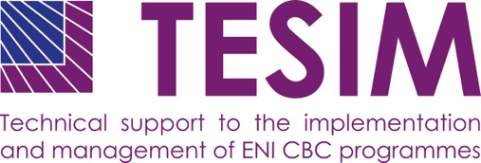
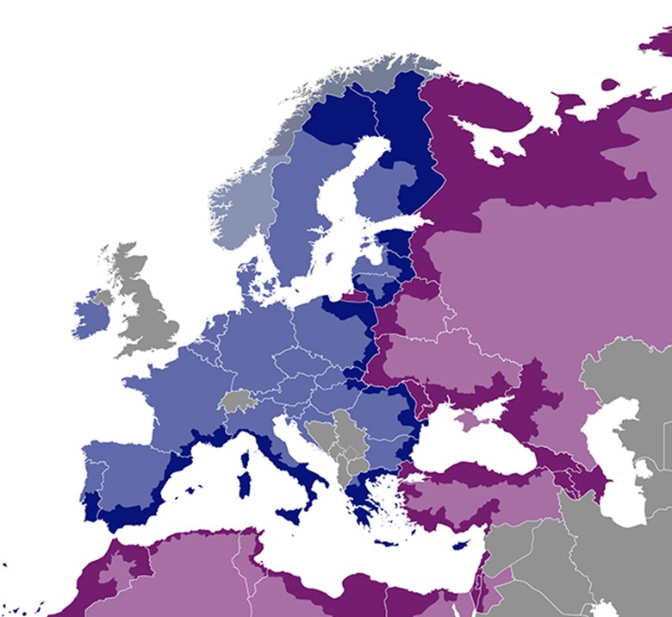
DISCLAIMER
This non-binding document has been developed by the TESIM project. It does not necessarily reflect the views of the European Commission on the topic, and is presented to programme and project practitioners for illustrative purposes only.
In case the document is endorsed by an ENI CBC programme and renders it compulsory for use by project beneficiaries, neither TESIM experts nor the TESIM consortium members shall be held liable for its contents, in particular as far as audit findings on the eligibility of expenditure are concerned.

Expenditure verification pack: expenditure and revenue verification procedure

Annex 1 to the adaptation for projects with subgrants of the “Fact sheet on expenditure and revenue verification report”

July 2020
A project funded by the European Union |  | Implemented by a consortium led by

Template of expenditure and revenue verification procedure for projects with subgrants

Introduction

Regulatory framework for the ENI CBC programmes sets the requirements for the verification procedures of declared expenditure and revenue. In particular, ENI CBC Implementing Rules (EC Regulation 897/2014) stipulates that expenditure shall be examined by an auditor or by a competent public officer being independent from the beneficiary.

As a result of the verification, it should be possible to conclude that the costs and the revenue declared by the beneficiary and the subgrantees are:

real (expenditure was really incurred and revenues are identified and quantified),

accurately recorded (amounts are stated and recorded according to the supporting documents), and

eligible (in line with eligibility criteria) in accordance with the Grant Contract and the Subgrant Contracts.

Grants awarded shall not have the purpose or effect of producing a profit, thus the expenditure verification procedure should include check of compliance with ‘no-profit principle’. Profit is defined a surplus between costs and receipts at the moment of the closure of the project.

If the beneficiary gets a contribution from a third party (like the State contribution) or generates revenues because of the project (for example, interest generated by pre-financing, charges for the use of the infrastructure developed in the project or fees for the use of services), it does not automatically mean that the no-profit principle is breached.
In accordance with article 192 of the Omnibus Regulation, the no-profit principle does not apply to low-value grants. Low-value grants are the ones below 60.000€, as stipulated in article 2(41) of the Omnibus Regulation. Therefore, it does not apply to subgrants.
Each payment request (except the first pre-financing request according to the signed contract) has to be accompanied with expenditure and revenue verification report. This verification shall be performed on the basis of an agreed upon procedure stipulated in the Grant Contract and the Subgrant Contracts.
The objective of an agreed-upon procedures engagement is for the auditor to carry out procedures of an audit nature to which the auditor and the entity and any appropriate third parties have agreed and to report on factual findings.
The subject of the verification is the financial report produced by a beneficiary where project expenditure and revenue are declared and reimbursement is sought for the eligible part of that expenditure, as well as checking the respect of the non-profit principle. The expenditure declared includes either:
- the payments to the subgrantees in case of financial regime with simplified costs, or
- the eligible expenditure declared by the subgrantees to the beneficiary in case of financial regime with reimbursement of costs.

The expenditure and revenue verification is organised in accordance with the verification procedures defined in a checklist and template for list of findings, as well as templates for the reports: expenditure and revenue verification report (consolidated and/or individual beneficiary, as relevant) and report on suspected and/or established fraud. The report on fraud needs to be sent directly to the Managing Authority (or Joint Technical Secretariat), without any need of informing the concerned beneficiary.

These provisions and documents are included in the annex of the contract between the beneficiary and the Managing Authority.

- Responsibilities of the Parties to the Engagement

The term “Beneficiary(ies)” refers collectively to all Beneficiaries of the project, including the Lead Beneficiary. Where applicable the term 'Beneficiary(ies) includes its affiliated entity(ies).

- The Beneficiary (and Lead Beneficiary when relevant) is responsible for providing a Financial Report for the project financed by the Grant Contract, which complies with the terms and conditions of the Grant Contract and for ensuring that this Financial Report reconciles to the Beneficiary’s accounting and bookkeeping system and to the underlying accounts and records. The Beneficiary is responsible for providing sufficient and adequate information, both financial and non-financial, in support of the Financial Report.
- The Beneficiary (and Lead Beneficiary when relevant) is responsible for integrating into its Financial Report the expenditure incurred and paid by the subgrantees, in compliance with the terms and conditions of the Subgrant Contracts.
- The Beneficiary (and Lead Beneficiary when relevant) accepts that the ability of the Auditor to perform the procedures required by this engagement effectively depends upon the Beneficiary(ies), and as the case may be its affiliated entity(ies), providing full and free access to its (their) staff and its (their) accounting and bookkeeping system and underlying accounts and records.
- The Beneficiary (and Lead Beneficiary when relevant) ensures that the subgrantees accept that the ability of the Auditor to perform the procedures required by this engagement effectively depends upon the subgrantee, providing full and free access to their staff, the supporting documents of the outputs produced (in case of simplified costs) and their accounting and bookkeeping system and underlying accounts and records (in case of reimbursement of costs).
- ‘The Auditor’ (or public officer, if relevant) is responsible for performing the agreed-upon procedures as specified in this procedure. ‘Auditor’ refers to the audit firm contracted for performing this engagement and for submitting a report of factual findings to the Beneficiary. 'Auditor' can refer to the person or persons conducting the verification, usually the engagement partner or other members of the engagement team. The engagement partner is the partner or other person in the audit firm who is responsible for the engagement and for the report that is issued on behalf of the firm, and who has the appropriate authority from a professional, legal or regulatory body.

- Engagement Type and Objective

This expenditure and revenue verification is an engagement to perform certain agreed-upon procedures with regard to the Financial Report for the Grant Contract. The objective of this expenditure verification is for the Auditor to carry out the specific procedures listed in the annex with the control checklist and to submit to the Beneficiary (or Lead Beneficiary, when relevant) a report of factual findings with regard to the specific verification procedures performed.
Verification means that the Auditor examines the factual information in the Financial Report of the Beneficiary (or Lead Beneficiary, when relevant) and subgrantees and compares it with the terms and conditions of the Grant Contract and the Subgrants Contracts. As this engagement is not an assurance engagement the Auditor does not provide an audit opinion and expresses no assurance. The Managing Authority assesses for itself the factual findings reported by the Auditor and draws its own conclusions from these factual findings.

- Standards and Ethics

The Auditor shall undertake this engagement in accordance with:
- the International Standard on Related Services (‘ISRS’) 4400 Engagements to perform Agreed-upon Procedures regarding Financial Information as promulgated by the IFAC;
- the IFAC Code of Ethics for Professional Accountants, developed and issued by IFAC’s International Ethics Standards Board for Accountants (IESBA), which establishes fundamental ethical principles for Auditors with regard to integrity, objectivity, independence, professional competence and due care, confidentiality, professional behaviour and technical standards. Although ISRS 4400 provides that independence is not a requirement for agreed-upon procedures engagements, the ENI CBC Implementing Rules requires that the Auditor is independent from the Beneficiary(ies) and subgrantees and complies with the independence requirements of the IFAC Code of Ethics for Professional Accountants.

- Evidence and Documentation

The Auditor plans the work so that an effective expenditure and revenue verification can be performed. The evidence to be used for performing the procedures in the control checklist is all financial and non-financial information which makes it possible to examine the expenditure and revenue declared by the Beneficiary (or Lead Beneficiary, when relevant) in the Financial Report.
The Auditor uses the evidence obtained from these procedures as the basis for the report of factual findings. The Auditor documents matters which are important in providing evidence to support the report of factual findings, and evidence that the work was carried out in accordance with ISRS 4400 and these procedures. The Managing Authority, the Control Contact Points of the country of the beneficiary and any other competent body of the European Union or duly authorised by them, may have access to the working papers of the Auditor to verify the quality of the work carried out.

Reporting

The report on this expenditure and revenue verification shall describe the purpose, the agreed-upon procedures and the factual findings of the engagement in sufficient detail to enable the Beneficiary (or Lead Beneficiary, when relevant) and the Managing Authority to understand the nature and extent of the procedures performed by the Auditor and the factual findings reported by the Auditor.
The use of the Model Report for the expenditure and revenue verification in annex to the contract with the beneficiary is compulsory.

General Procedures

Terms and Conditions of the Grant Contract
The Auditor:
- obtains an understanding of the terms and conditions of the Grant Contract by reviewing the Grant Contract and its annexes and other relevant information, and by inquiry of the Beneficiary;
- obtains a copy of the original Grant Contract and the Partnership Agreement;
- obtains a copy of the documents of the call for subgrants (including evaluation and contracting) and the Subgrant Contracts;
- obtains and reviews the Financial Report (which includes a narrative and a financial section);
- verifies whether there is (are) an affiliated entity(ies) to the Beneficiary(ies).

  - Verification evidence
When performing the specific procedures listed in control checklist, the Auditor may apply techniques such as inquiry and analysis, (re)computation, comparison, other clerical accuracy checks, observation, inspection of records and documents, inspection of assets and obtaining confirmations.
The Auditor obtains verification evidence from these procedures to draw up the report of factual findings. Verification evidence is all information used by the Auditor in arriving at the factual findings and it includes the information contained in the accounting records underlying the Financial Report and other information (financial and non-financial).
The contractual requirements that relate to verification evidence are:
- Expenditure should be identifiable, verifiable and recorded in the accounting records of the Beneficiary and the subgrantees (in case of financial regime of reimbursement of costs);
- The Beneficiary and subgrantees will allow any external auditor to carry out verifications on the basis of supporting documents for the accounts, accounting documents and any other document relevant to the financing of the project. The Beneficiary and subgrantees gives access to all documents and databases concerning the technical and financial management of the project;
- Moreover, for the purpose of the procedures listed in control checklist, records, accounting and supporting documents:
- shall be easily accessible and filed so as to facilitate their examination;
- shall be available in the original form or in the form of copies, including in electronic form.
- records and accounting and supporting documents should be available in documentary form, whether paper, electronic or other medium (e.g. a written record of a meeting is more reliable than an oral presentation of the matters discussed). Electronic documents can be accepted only where:
- the documentation was first received or created (e.g. an order form or confirmation) by the Beneficiary and subgrantees in electronic form; or
- the Auditor is satisfied that the Beneficiary and subgrantees use an electronic archiving system which meets established standards (e.g. a system which complies with national law).
- should preferably be obtained from independent sources outside the entity (an original supplier’s invoice or contract is more reliable than an internally approved receipt note);
- which is generated internally is more reliable if it has been subject to control and approval;
- obtained directly by the Auditor (e.g. inspection of assets) is more reliable than evidence obtained indirectly (e.g. inquiry about the asset).
- If the Auditor finds that the above criteria for evidence are not sufficiently met, he/she should detail this in the factual findings.
  - Verification coverage of expenditure and selection of expenditure items
The Auditor applies the principles and criteria set out below when planning and performing the specific verification procedures for selected expenditure. Value should be the principal factor used by the Auditor to select expenditure items or classes of expenditure items for verification. The Auditor selects high-value expenditure items to ensure an appropriate coverage of expenditure.
Verification by the Auditor and verification coverage of expenditure items does not necessarily mean a complete and exhaustive verification of all the expenditure items that are included in a specific expenditure heading or subheading. The Auditor should ensure a systematic and representative verification. Depending on certain conditions (see further below) the Auditor may obtain sufficient verification results for an expenditure heading or subheading by looking at a limited number of selected expenditure items.
The Auditor may apply sampling techniques for the verification of one or more expenditure headings or subheadings of the Financial Report. The Auditor examines whether ‘populations’ (i.e. expenditure subheadings or classes of expenditure items within expenditure subheadings) are suitable and sufficiently large (i.e. are made up of large numbers of items) for effective sampling.
If applicable the Auditor should explain in the report of factual findings for which headings or subheadings of the Financial Report sampling has been applied, the method used, the results obtained and whether the sample is representative.
The Expenditure Coverage Ratio (‘ECR’) is the total amount of expenditure verified by the Auditor, expressed as a percentage of the total amount of expenditure reported by the Beneficiary in the Financial Report.
The Auditor ensures that the overall ECR is at least 65 %. If he/she finds an exception rate of less than 10 % of the total amount of expenditure verified (i.e. 6.5 %) the Auditor finalises the verification procedures and continues with reporting.
If the exception rate found is higher than 10 % the Auditor extends verification procedures until the ECR is at least 85 %. The Auditor then finalises verification procedures and continues with reporting regardless of the total exception rate found. The Auditor ensures that the ECR for each expenditure heading and subheading in the Financial Report is at least 10 %.
  - Findings
The Auditor verifies the selected expenditure items by carrying out procedures listed in the control checklist and reports all the factual findings and exceptions resulting from these procedures. Verification exceptions are all verification deviations found when performing the procedures.
The Auditor quantifies the amount of verification exceptions found and the potential impact on the EU contribution, should the Managing Authority declare the expenditure item(s) concerned ineligible (taking into account the percentage of funding by the Commission and the impact on indirect expenditure (e.g. administrative costs, overheads)). The Auditor reports all exceptions found, including those for which he/she cannot quantify the amount of the verification exception found and the potential impact on the EU contribution.

See paragraph above on the non-applicability to subgrants
Only in the case of subgrants under the financial regime of reimbursement of costs
In accordance with the conditions of article 122 of the Financial Regulation (Regulation 966/2012)
The auditor shall check the originals at least once in the lifetime of the project
The auditor shall do a personal inspection of any assets acquired by the project (e.g. computers or infrastructure), at least once during the lifetime of the project

