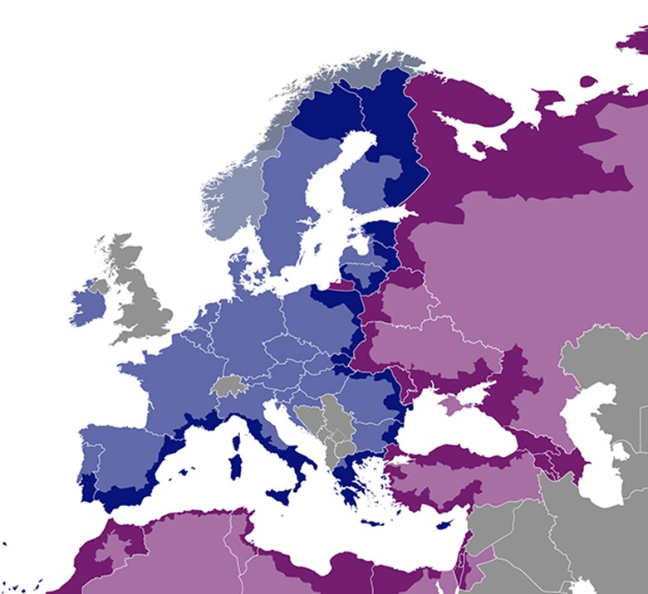

Expenditure verification pack: list of factual findings

Annex 5 to the adaptation for projects with subgrants of the “Fact sheet on expenditure and revenue verification report”

  - July 2020
DISCLAIMER
This non-binding document has been developed by the TESIM project. It does not necessarily reflect the views of the European Commission on the topic, and is presented to programme and project practitioners for illustrative purposes only.
In case the document is endorsed by an ENI CBC programme and renders it compulsory for use by project beneficiaries, neither TESIM experts nor the TESIM consortium members shall be held liable for its contents, in particular as far as audit findings on the eligibility of expenditure are concerned.
A project funded by the European Union |  | Implemented by a consortium led by

Template of list of factual findings

Annex 2 ‘Factual findings’
Financial Report <dd Month yyyy — dd Month yyyy>
Grant Contract <title and number of the contract>
Expenditure
Main budget heading (Staff, Travel & subsistence, subgrants, etc.) | Identification of expenditure (reference to project accounting) |  |  | Non-accepted amount of expenditure |  |  |  | Legal provision / eligibility rule breached |  | Description of the reasons for non-acceptance |  | <other fields if needed>
 | Date | Number | Document
Total |  |  |  | 0,000.00

Income
 | Amount |  |  | Findings or comments, if relevant
EU contribution
Contribution from third parties (i.e. state budget)
Revenues
Interest generated by pre-financing received
Own contribution
Total income
Profit
 |  | Amount | Comments, if needed
Total eligible expenditure |  |  | N/A
Total income
Difference between income and expenditure (profit)
Conclusion as to whether no-profit principle is observed, including (if applicable) the profit that should be deducted from payment claim

